e-PU10 V2
Passive Gas Venting Calculations
Corrected Multi-Gas Pressure Model

Engineering Calculation Report - Revision 2 (updated model)
Subject: Thermal runaway gas venting assessment of the e-PU10 container
Document type: Design review calculation report

This revision corrects the pressure calculation of the earlier updated model. Previously the internal pressure build-up was computed from the hydrogen release only. Thermal runaway, however, releases several gases (H₂, CO₂, CO and hydrocarbons) that all contribute to the total number of gas molecules and therefore to the pressure. The pressure balance now includes all released gases, while the hydrogen concentration – which governs the explosion risk – continues to be evaluated from hydrogen alone.

1 Introduction
This document presents the corrected calculations used to assess the passive gas-venting safety of the e-PU10 battery container during a cell or module thermal runaway. When a battery cell enters thermal runaway it releases a large volume of hot, flammable and toxic vent gas over a short time. Inside the closed e-PU10 container (free volume 8.067 m³) this creates two coupled hazards that must both be controlled by design: a rise in flammable-gas concentration and a rise in internal pressure.
The hazards evaluated are:
- Hydrogen explosion risk – hydrogen has the widest flammability range and the lowest ignition energy of the vented species, so it governs the flammable-gas hazard. A conservative working limit of 25% of the LEL is applied: C_H2 < 1 %vol.
- Toxic gas exposure – the vent gas also contains carbon monoxide (CO) and other toxic products which must be diluted and removed to protect personnel and equipment.
- Pressure build-up (overpressure) – the sudden release of all gas species raises the internal pressure; if the container cannot relieve this pressure it may be structurally damaged. All released gases contribute to this pressure, not hydrogen alone.
Passive venting is investigated because it has no moving parts, requires no power, cannot fail to start, and is therefore inherently more reliable during a fault condition than an active fan. The purpose of this report is to determine the minimum passive vent area that keeps the hydrogen concentration below 1 %vol throughout the release while safely relieving the pressure produced by the complete gas mixture.
Correction in this revision: the previous updated model sized the vent on a pressure build-up computed from hydrogen only. That underestimates the true pressure, because CO₂, CO and hydrocarbons also add molecules to the container. Including all gases raises the internal pressure, increases the pressure difference across the vent, and therefore increases the pressure-driven venting flow. The net effect is that the same hydrogen-concentration limit is met with a smaller vent area than previously calculated.

2 Gas release composition
The gas release data are taken from the UL 9540A module report (“4790880512-UL 9540A Module Report-final version.pdf”). Hydrogen is supplied to the model as a measured time-dependent volumetric flow profile (H2_profile.csv); the total hydrogen volume released over the event is 0.2428 m³ (242.8 L). The additional gas volumes released during the same event are listed below. CO₂, CO and hydrocarbons are assumed to follow exactly the same time-dependent release profile as hydrogen.
Gas | Release volume | Used for H₂ concentration | Used for pressure
H₂ (hydrogen) | 0.2428 m³ (242.8 L) | Yes | Yes
CO₂ (carbon dioxide) | 0.07875 m³ (78.75 L) | No | Yes
CO (carbon monoxide) | 0.24640 m³ (246.40 L) | No | Yes
HC (total hydrocarbons) | 0.26195 m³ (261.95 L) | No | Yes
Total | 0.8299 m³ (829.9 L) | H₂ only | All species
Table 1 Gas release composition and its use in the two calculations.
Why the gases are treated differently:
The hydrogen concentration is the explosion criterion. Hydrogen is the critical flammable species, so only hydrogen is counted when checking C_H2 < 1 %vol; adding the other gases to the hydrogen concentration would be physically wrong and would misstate the flammability margin. The pressure, in contrast, is a property of the total gas quantity: every molecule of H₂, CO₂, CO and HC occupies the same container and pushes on its walls, so all species must be included in the pressure (ideal-gas) balance. Because CO₂, CO and HC together add about 2.4 times the hydrogen volume, the total generated gas volume is about 3.42 times the hydrogen volume (gas factor = 3.4185), which is exactly the factor by which the pressure source term is increased relative to the hydrogen-only model.

3 Calculation methodology
The model integrates the coupled gas balance forward in time with a fixed step Δt = 1 s. At each step it evaluates: (i) the internal pressure and the pressure difference across the opening, (ii) the pressure-driven vent flow, (iii) the diffusive exchange flow, (iv) the hydrogen mass balance and concentration, and (v) the updated internal pressure from the total-gas ideal-gas law.

3.1 Gas generation
Hydrogen generation is the prescribed source term S(t) [m³/s] from the measured profile:
$$\frac{dV_{H2}}{dt} = S(t)$$
CO₂, CO and HC share the hydrogen release shape, so the total (all-species) generation rate is the hydrogen rate scaled by the ratio of total released volume to hydrogen volume:
$$gas_{factor}=\frac{V_{H2}+ V_{CO2}+ V_{CO}+ V_{HC}}{V_{H2}} = 3.4185$$
$$S_{total}(t) = gas_{factor} · S(t)$$

3.2 Total gas balance and pressure (ideal gas law)
The internal pressure follows from the ideal-gas law applied to the total gas amount:
$$P · V = n_{total} · R · T ,$$
$$n_{total} = n_{H2} + n_{CO2} + n_{CO} + n_{HC} + n_{air}$$
The initial gas charge (air) is n_initial = P_atm·V/(R·T). The excess moles accumulate the balance between total gas generated and gas expelled by the pressure-driven vent flow:
$$n_{generated} = S_{total}\left(t\right)·\frac{P_{atm}}{R·T}$$
$$n_{removed} = Q_{pressure} ·\frac{P_{inside}}{R·T}$$
$$n_{extra} ← max\left( n_{extra} + \left(n_{generated} - n_{removed}\right)·Δt , 0\right)$$
$$P_{inside} = \left(n_{initial} + n_{extra}\right)· R ·\frac{T}{V}$$
Only the pressure-driven flow removes net moles; the diffusive exchange is bidirectional and does not represent net expulsion.

3.3 Hydrogen concentration (H₂ only)
Hydrogen mixes instantaneously and uniformly. Its volume fraction uses hydrogen alone:
$$C_{H2}=\frac{V_{H2}}{V_{container}}$$
$$C_H2[i] = max\left( C_{H2}\left[i-1\right]+\frac{ S\left(t\right)·Δt - C_{H2}\left[i-1\right]·Q_{total}·Δt }{V_{container}} , 0 \right)$$
CO₂, CO and HC are deliberately excluded from this equation.

3.4 Vent flow calculation (sharp-edged orifice)
The opening is a sharp-edged circular hole; the small ΔP keeps the flow incompressible, so the orifice (Bernoulli) equation applies:
$$Q = C_{d} · A · \sqrt{ 2·\frac{ΔP}{ρ}}$$
- Q = volumetric flow through the opening [m³/s]
- C_d = 0.65, discharge coefficient of a sharp-edged hole [–]
- A = vent opening area [m²]
- ΔP = P_inside − P_atm, pressure difference [Pa] (floored at 0)
- ρ = 1.2 kg/m³, gas density used in the orifice equation
Because the multi-gas model produces a higher ΔP than the hydrogen-only model, the pressure-driven flow Q is larger, which improves passive venting.

3.5 Gas exchange with outside air
Even without a pressure difference, gas is exchanged across the opening (hydrogen out, fresh air in). This buoyancy/diffusion exchange is modelled proportional to the opening area:
$$Q_{diff} = k_{diff} · A , k_{diff} = 0.15 m³/s per m²$$
$$Q_{total} = Q_{pressure} + Q_{diff}$$
The diffusive exchange is the dominant concentration-reduction mechanism once the pressure transient decays, continuously replacing hydrogen-laden air with clean external air.

4 Assumptions
Assumption | Explanation
Instantaneous mixing | Conservative, simplified uniform gas distribution in the 8.067 m³ volume
Constant temperature (293 K) | Ideal-gas approximation; hot vent gas addressed as a limitation
Ideal gas behaviour | Used for the total-gas pressure calculation (PV = nRT)
Sharp-edged circular vent | Used for the orifice flow equation with C_d = 0.65
Passive ventilation | No fan assistance; flow driven only by pressure and diffusion
Same release profile | CO₂, CO and HC follow the H₂ time-dependent release profile
All gases in pressure | H₂+CO₂+CO+HC all add molecules and contribute to pressure
H₂ only in concentration | Only hydrogen governs the explosion criterion (C_H2 < 1 %vol)
Constant density (1.2 kg/m³) | Fixed value required for the orifice flow calculation
Incompressible flow | Justified because ΔP stays far below the choking threshold
Quiescent external air | Standard air at P_atm, T outside the container
Container volume 8.067 m³ | Given design value from the e-PU10 volume model
Table 2 Model assumptions.

5 Python model (gasventing.py)
The calculation is implemented in gasventing.py (NumPy / pandas / matplotlib). The script reads the hydrogen generation profile, derives the total-gas generation rate from the release composition, runs the time-stepping simulation for a set of candidate vent areas, and plots the hydrogen concentration and pressure histories.
Variable | Unit | Initial value | Description
V_con | m³ | 8.067 | Free container volume
dt | s | 1.0 | Simulation time step
Cd | – | 0.65 | Orifice discharge coefficient
rho | kg/m³ | 1.2 | Gas density used in the orifice equation
P_atm | Pa | 101325 | Atmospheric (reference) pressure
T | K | 293 | Constant gas temperature
R | J/(mol·K) | 8.314 | Universal gas constant
k_diff | m³/s per m² | 0.15 | Diffusion/exchange coefficient per unit area
H2_gen | m³/s | from CSV | Hydrogen generation rate S(t)
V_H2_total | m³ | 0.2428 | Total hydrogen volume released
V_CO2 / V_CO / V_HC | m³ | 0.07875 / 0.24640 / 0.26195 | Additional released gas volumes
gas_factor | – | 3.4185 | Ratio of total gas volume to hydrogen volume
total_gen | m³/s | H2_gen·gas_factor | Total (all-species) generation rate for pressure
areas | m² | [0,0.01,0.02,0.03,  0.04,0.05,0.06,0.08] | Candidate vent areas compared
CH2 | – | 0 | Hydrogen volume fraction history
P_inside | Pa | P_atm | Internal pressure history
n_initial | mol | P_atm·V/(R·T) | Initial moles of air in the container
n_extra | mol | 0 | Accumulated excess moles above the initial charge
deltaP | Pa | computed | Pressure difference across the opening (≥0)
Q_pressure | m³/s | computed | Pressure-driven orifice flow
Q_diff | m³/s | computed | Diffusive/exchange flow (k_diff·A)
Q_total | m³/s | computed | Total exchange flow (Q_pressure + Q_diff)
n_generated | mol/s | total_gen·P_atm/(R·T) | Total moles generated in the step (all gases)
n_removed | mol/s | Q_pressure·P/(R·T) | Moles expelled by the pressure-driven flow
Table 3 Variables in gasventing.py.

5.1 Timestep calculation
- Add gas generation – read the hydrogen rate S(t) and form the total-gas rate S_total(t) = gas_factor·S(t).
- Calculate total gas amount – convert the total generation to moles n_generated and accumulate n_extra.
- Calculate pressure – P_inside = (n_initial + n_extra)·R·T/V, giving ΔP = P_inside − P_atm.
- Calculate pressure-driven vent flow – Q_pressure = C_d·A·√(2·ΔP/ρ); add Q_diff = k_diff·A to get Q_total.
- Remove gases through the vent – subtract n_removed = Q_pressure·P_inside/(R·T) from the pressure balance.
- Calculate hydrogen concentration – update C_H2 from hydrogen generated minus hydrogen removed (C_H2·Q_total), H₂ only.
- Continue simulation – advance to the next step and store the histories once the area is complete.

6 Results
The simulation was run for the candidate vent areas with the corrected multi-gas pressure model. Figure 1 shows the hydrogen concentration, Figure 2 the internal pressure rise, and Figure 3 compares the sealed-container pressure of the hydrogen-only and multi-gas models. Table 4 summarises the peak values.
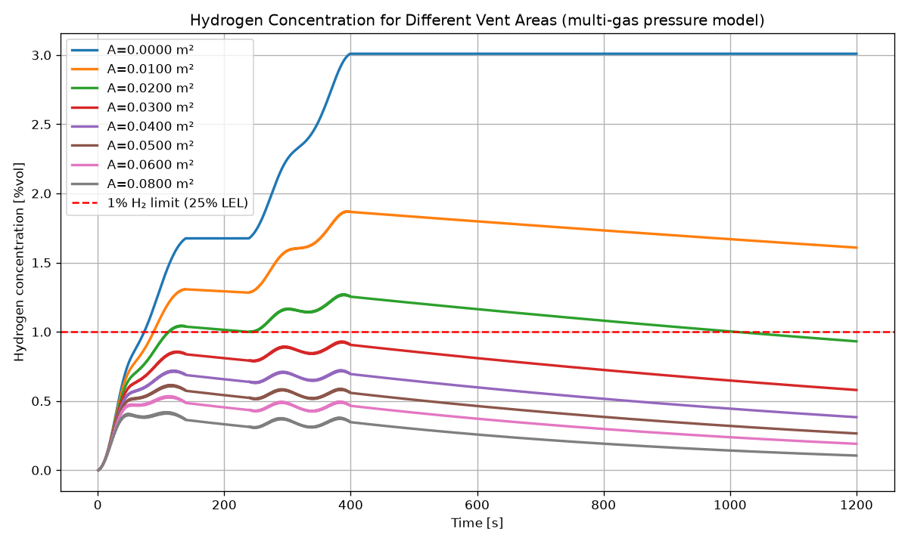
Figure 1 Hydrogen concentration vs time for different vent areas (multi-gas pressure model). Dashed red line = 1 %vol (25% LEL) limit.
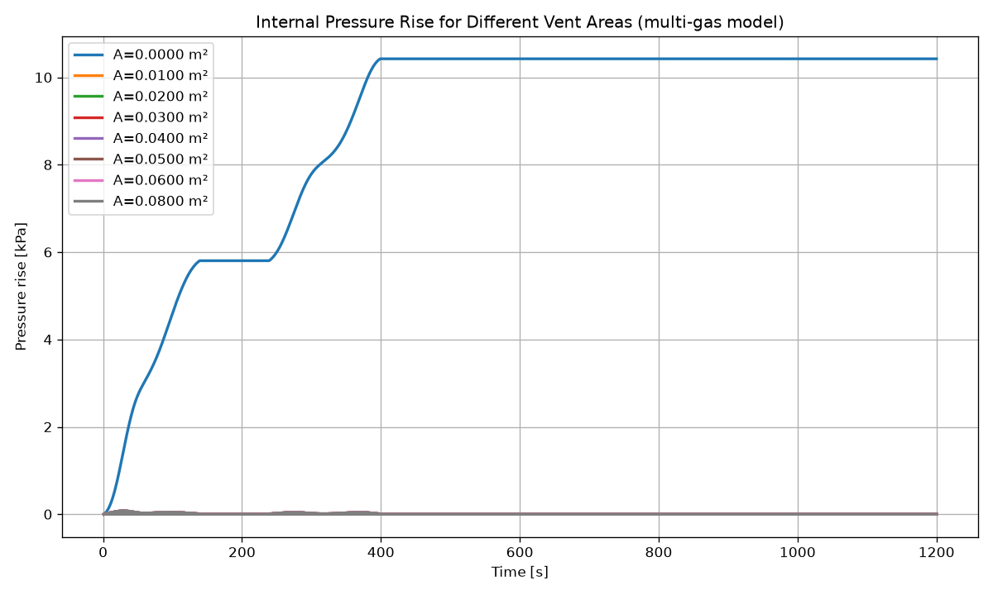
Figure 2 Internal pressure rise vs time for different vent areas (multi-gas model).
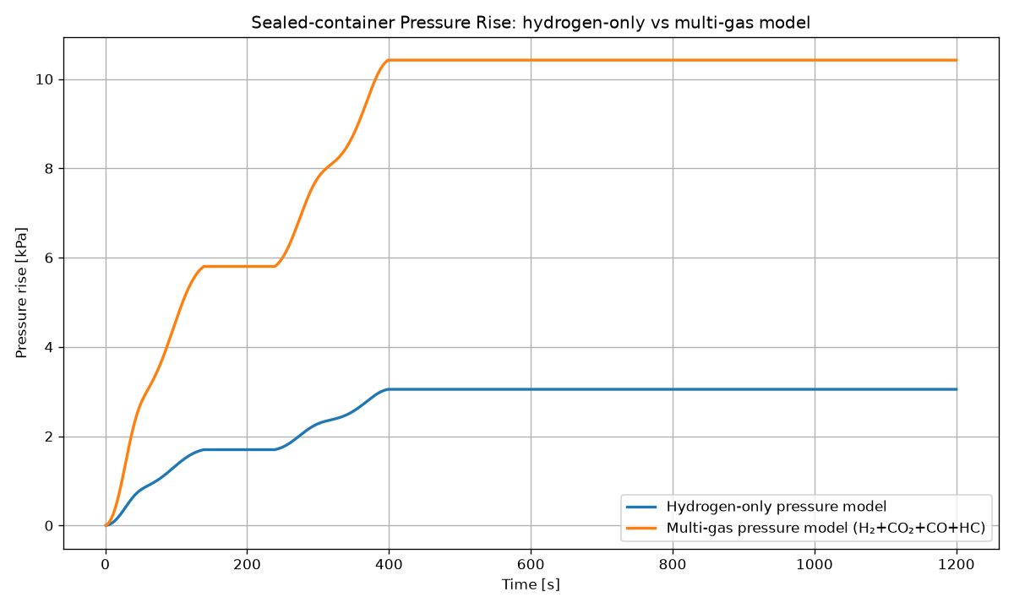
Figure 3 Sealed-container pressure rise: hydrogen-only model (3.05 kPa) vs corrected multi-gas model (10.42 kPa).

Vent area A [m²] | Peak H₂ concentration [%vol] | Peak pressure rise [kPa] | Below 1% limit?
0.00 (sealed) | 3.01 | 10.42 | No
0.01 | 1.87 | 0.079 | No
0.02 | 1.27 | 0.079 | No
0.03 | 0.93 | 0.079 | Yes
0.04 | 0.72 | 0.079 | Yes
0.05 | 0.62 | 0.079 | Yes
0.06 | 0.54 | 0.079 | Yes
0.08 | 0.42 | 0.079 | Yes
Table 4 Peak hydrogen concentration and pressure rise per vent area (multi-gas model).

6.1 Hydrogen-only vs multi-gas pressure model
In the sealed case the corrected multi-gas model raises the peak pressure from 3.05 kPa (hydrogen-only) to 10.42 kPa – a factor of 3.42, exactly the gas factor, confirming the correction. Once a finite opening is present the peak pressure collapses to a small value in both models (about 79 Pa in the multi-gas model vs 23 Pa hydrogen-only), because even a small orifice vents the gas at a low pressure difference. The higher ΔP in the multi-gas model produces a larger pressure-driven flow, which also helps remove hydrogen. As a result the hydrogen concentration for a given area is lower than in the hydrogen-only model, and the 1 %vol limit is met at a smaller vent area.

6.2 New required vent area
With the corrected model the smallest studied area that keeps the peak hydrogen concentration below 1 %vol is 0.03 m² (0.93 %vol). The threshold is crossed at about A ≈ 0.028 m². A vent area of 0.03 m² is therefore recommended, replacing the previous 0.05 m². This is a 40% reduction in required area, driven by the additional pressure-driven venting from the full gas mixture.
Model | Required vent area
Previous hydrogen-only pressure model | 0.05 m²
Updated multi-gas pressure model | 0.03 m²
Table 5 Required vent area: hydrogen-only vs corrected multi-gas model.

7 Final recommendation
A passive vent opening with a minimum net free area of 0.03 m² is recommended for the e-PU10 container. A modest margin (towards ~0.04 m² of net free area) is advisable to cover manufacturing tolerance, partial blockage and modelling uncertainty. A circular hole of 0.03 m² corresponds to a diameter of about 0.195 m (Ø ≈ 195 mm); the same area may be distributed over several smaller openings. Because hydrogen is buoyant, the vent(s) should be placed high on the enclosure. The quoted area is the net effective (open) area after any grille, mesh or membrane is accounted for.
Implementation option | Description | Main trade-off
Vent panel (louvred) | Fixed open area with a weather louvre | Simplest and most reliable; louvre reduces effective area so the physical opening must be larger
Filtered vent | Opening with particulate/toxic-gas filtration | Protects against dust and toxic CO release; filter adds resistance and needs maintenance
Pressure relief membrane | Breathable hydrophobic membrane | Excellent water/dust ingress protection; adds flow resistance, so effective area is reduced
Weather-resistant vent (hood/labyrinth) | Cowl or labyrinth path over the opening | Maintains ingress protection with low flow penalty; adds size and manufacturing complexity
Flame arrestor | Mesh element preventing flame propagation | Guards against external ignition propagation; increases pressure drop, reducing effective area
Table 6 Passive venting implementation options and trade-offs.
Environmental and safety protection:
- Dust protection – a louvre, filter or membrane keeps particulate ingress out; size the physical opening to preserve 0.03 m² of net area after the element resistance.
- Water ingress protection – a downward-facing louvre, weather hood/labyrinth or hydrophobic membrane prevents rain entry while allowing gas exchange.
- Flame propagation risk – a flame arrestor at the opening prevents an external ignition from propagating into the enclosure; the vent should also be sited away from ignition sources.

8 Critical engineering review
Mathematical correctness:
- Sealed-case mass-balance check: the multi-gas plateau pressure (10.42 kPa) equals the hydrogen-only value (3.05 kPa) times the gas factor (3.4185), and the hydrogen plateau concentration (3.01 %vol) equals 0.2428 m³ ÷ 8.067 m³ = 3.01 %vol. Both balances are internally consistent.
- Flow regime: peak ΔP is ~79 Pa, far below the compressibility/choking threshold, so the incompressible orifice equation is valid.
- Separation of concerns: pressure uses total moles (all species); hydrogen concentration uses hydrogen only – the physically correct treatment for each quantity.
Is the approach conservative?
Yes. Including all gases in the pressure calculation while evaluating only hydrogen for the flammability limit is a conservative vent-sizing approach. The extra CO₂, CO and HC increase the internal pressure and hence the pressure-driven venting; if these gases were (wrongly) ignored in the pressure balance, the model would predict less venting and would therefore demand a larger vent area. By crediting the additional pressure but not diluting the hydrogen criterion with non-hydrogen gases, the model neither over-credits the flammability margin nor under-credits the pressure relief. The resulting 0.03 m² is a safe (if anything, generous) requirement for the hydrogen limit.
Remaining uncertainties and possible improvements:
- Real gas-mixture properties – the orifice density (1.2 kg/m³) and ideal-gas assumption are approximations; the true mixture is lighter and hotter. Using real mixture density would mainly affect the (already tiny) pressure-driven flow, not the conclusion.
- Transient temperature effects – hot vent gas raises pressure and buoyancy transiently; higher buoyancy aids diffusive venting, while higher temperature raises pressure. Given the small computed ΔP, the net effect on required area is minor but should be confirmed.
- Compressible flow – not required here (ΔP ≪ choking threshold), but a check at the peak instant confirms incompressible flow is adequate.
- Non-uniform mixing – the well-mixed assumption can under-predict local hydrogen pockets near the source and ceiling; this is the most important limitation and is mitigated by design margin and high vent placement. CFD verification is recommended.
- Real vent-component behaviour – louvres, membranes, filters and arrestors reduce the effective C_d/area; the physical opening must be enlarged to preserve 0.03 m² net area.
- Empirical diffusion coefficient – k_diff = 0.15 m³/s per m² directly drives the concentration decay and should be validated against CFD or test data.
None of these effects overturns the conclusion: the pressure hazard is comfortably relieved by any modest opening, and a passive area of about 0.03 m² keeps the bulk hydrogen concentration below 1 %vol throughout the release.

9 Conclusion
The corrected multi-gas model gives the following conclusions:
- Correction: the pressure build-up now includes all released gases (H₂, CO₂, CO, HC), raising the sealed-container pressure from 3.05 kPa to 10.42 kPa (gas factor 3.4185). Hydrogen alone is still used for the explosion-concentration criterion.
- Required passive vent area: approximately 0.03 m² of net free area keeps the peak hydrogen concentration below the 1 %vol limit (0.93 %vol), down from the previous 0.05 m².
- Expected performance: with a 0.03 m² opening the internal pressure rise is negligible (≈ 79 Pa), so overpressure is not a concern, and the container is progressively flushed after the event by buoyancy/diffusion exchange.
- Recommended implementation: a weather-protected, high-mounted passive louvred vent (optionally with a flame arrestor and/or filter for CO), sized so the net free area is at least 0.03 m² after allowing for any grille, membrane or filter; a small margin (towards ~0.04 m²) is advised.
- Remaining safety considerations: validate k_diff against CFD/test data, account for local hydrogen stratification through vent placement and margin, and address toxic CO exposure via filtration or monitoring if required.
In summary, correcting the pressure model to include all thermal-runaway gases both increases the predicted internal pressure and improves passive venting performance, allowing the hydrogen-safety requirement (C_H2 < 1 %vol throughout the release) to be met with a passive vent area of about 0.03 m² for the e-PU10 container.

